Overview

One or more IntelliLogger Interface Modules such as the ILIM-2 and ILIM-7 (ILIM-x) can be attached to the back of an IntelliLogger instrument (Fig 1). The following procedure details the attachment process using the Module Attachment Bracket kit (LBI Part Number: 3539.30000).

The Module Attachment Bracket kit includes one angle bracket and four 4-40 machine screws. A Module Attachment Bracket kit is required for each module to be attached.

Multiple ILIM-x modules can be attached to a single IntelliLogger or attached to each other. The assembly process is essentially the same as the following.

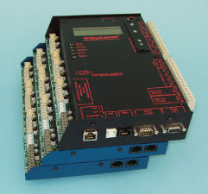

Fig : IntelliLogger with multiple attached ILIM-x Modules

Note: Take special handling care during assembly to prevent scratches or other damage to the metal work and circuitry.

Installation Instructions

1. If a Surface Mounting Plate is installed on the IntelliLogger, remove it before starting this procedure and reinstall after.
2. Remove the faceplate from the ILIM-X unit by removing the seven black anodized screws notated in Fig 2; two from the top of the ILIM-X, two from the bottom of the ILIM-X, and three from the side of the ILIM-X. Make sure to keep these screws as they will be reinstalled later.

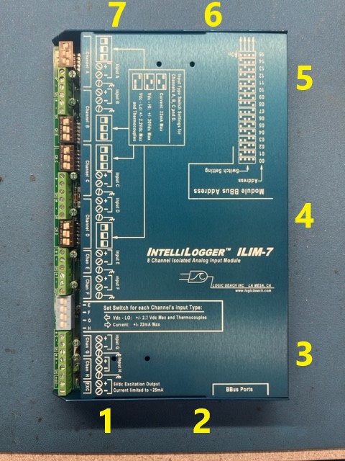

Fig : ILIM-x machine screw locations

1. Place the ILIM-X faceplate’s screened side against the back plate of the IL/ILIM unit such that the orientation/placement follows that of . This allows the fuses and switches of each module to stick out from the system in a “stair-like” pattern.

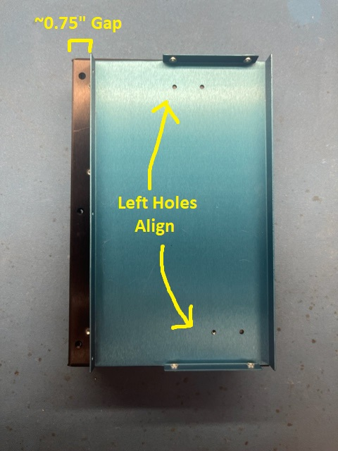

Fig : ILIM-X Faceplate Attachment to the IL/ILIM Back Plate

1. Using the two silver screws (3509.03003) that are provided, attach the ILIM-X faceplate to the back plate of one of the associated units in . Using the **left** two holes on the inside of the ILIM-X faceplate to attach an IL-10/20/80/90 or ILIM-X back plate.

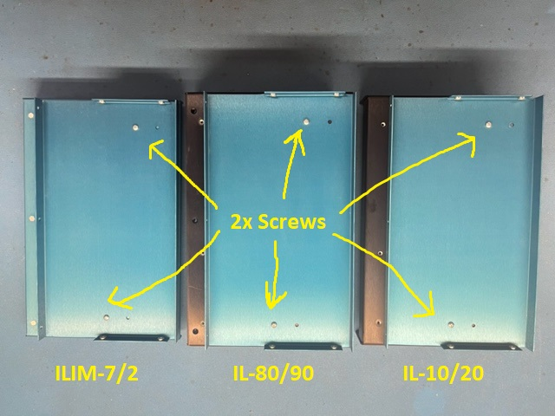

Fig : IL-10/20/80/90 or ILIM-X Back Plate Attachment

Note: IL-10/20 back plates are narrower due to a lack of extra channels and thus will force the ILIM-7/2 faceplate to hang over the edge further.

1. Place the angle bracket (3539.30000) such that the five holes in the bracket line up between the ILIM-X’s face plate and the IL/ILIM unit’s back plate as shown in . Secure the angle bracket using the two identical black anodized screws (3509.00002) that are provided with the stair step bracket.

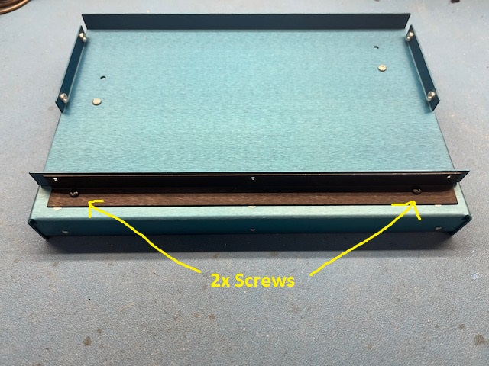

Fig : Angle Bracket Installation

1. The rest of the ILIM-X that was separated from the face plate can be reattached to the face plate by replacing the seven original black anodized screws that were removed at the beginning of the installation in step 1 as shown in . With the 3, 4 and 5 screws on the side now going through and reinforcing the stair step bracket.

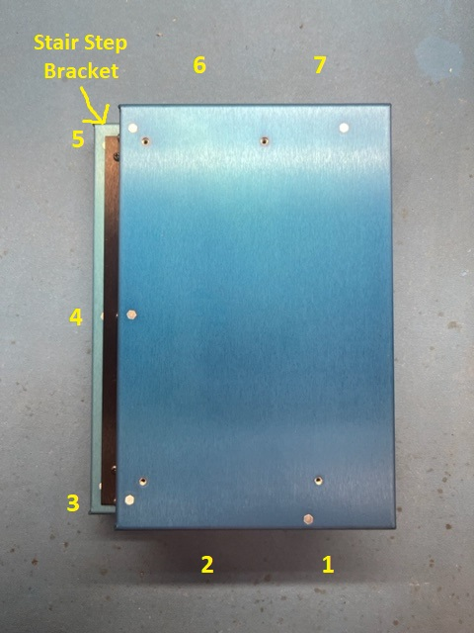

Fig : ILIM-X Unit Reattachment to the System

1. Steps 2-6 can be repeated for any additional angle brackets and associated units to be stacked in a system together.

Note: A mounting plate can be added to the final unit in a stacked system if a mounting plate was removed during step 1. In addition, only the 2 silver (3509.03003) screws may be required for a single ILIM unit addition as the weight can be supported by the screws without the need for reinforcement from the stair step bracket.

Document Revision History

10-03-2024: First release of document

5-30-2025: Fixed Figure 1 Link that was causing an issue when printed